|  |  |  |  |
| --- | --- | --- | --- |
| Date: |  | Date of Injury: |  |
| Employee Name: |  | Time of Injury: |  |
| Department: |  | Supervisor Name: |  |

Circle and comment on the injured body part in the diagram below

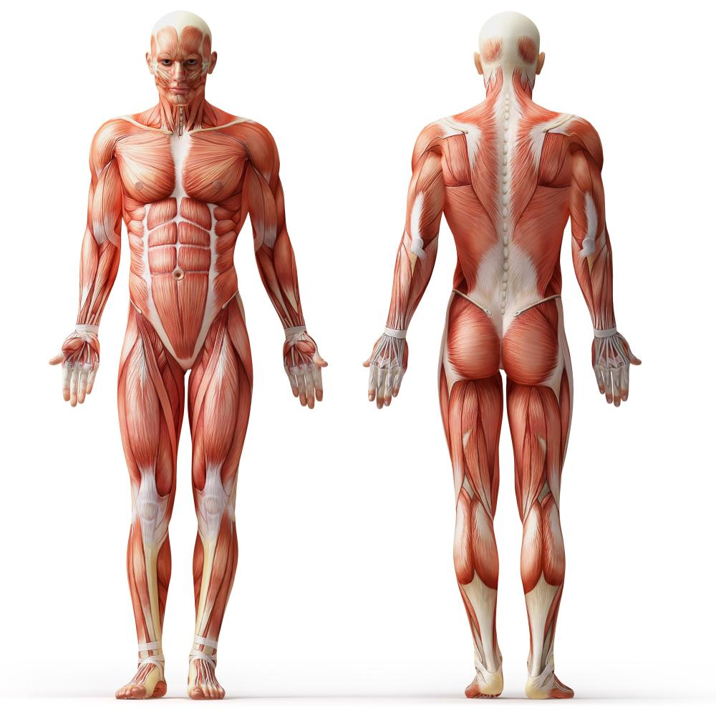

RIGHT

LEFT

RIGHT

PAIN LEVEL: 0 1 2 3 4 5 6 7 8 9 10

(Circle the number that best describes your current pain level)

|  |
| --- |
| Comments: |

On , and incident occurred at in which I sustained a minor injury. I spoke with my Supervisor , who asked if I would like to see a physician for my injury. At this time, I advised that I am in good health, feeling fine, and declined medical treatment.

If in the future I feel pain, or would like to seek medical attention for the injury above, I will contact my supervisor for direction.

Signature of employee: Date: ________________

Signature of supervisor: Date: ________________